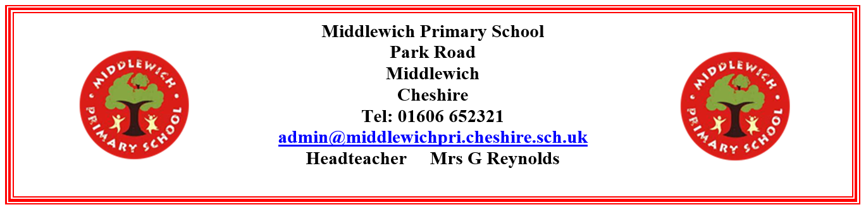
Wednesday 17th September

Dear Parents and Carers,

Income-Related Free School Meals (IRFSM)
At our school, we want every child to have the best possible education and access to opportunities. One of the ways we can achieve this is through additional funding called Pupil Premium, which is provided to schools based on the number of children eligible for income-related free school meals (IRFSM).

By registering for IRFSM, your child would be entitled to free school trips, including residential visits. Even if your child does not choose to have a free school meal, registering for IRFSM could still mean our school receives additional funding to support pupils’ learning.

You can claim free school meals for each child who attends school if you receive one of these benefits:
- Universal Credit with no earned income or with net monthly earnings less than £616.67
- Income Support
- Income based Jobseeker's Allowance
- Income related Employment Support Allowance
- Support under Part VI of the Immigration and Asylum Act 1999
- The guaranteed element of State Pension Credit
- Child Tax Credit - as long as you have a yearly household income of less than £16,190 (as assessed by HM Revenue and Customs) and do not get Working Tax Credit
- Working Tax Credit run-on (paid for 4 weeks after you stop qualifying for Working Tax Credit)

The process to apply is completely confidential. You can apply or check if you are eligible for IRFSM by telephoning 0300 123 5012. Full eligibility details, more information and online application form are available here: https://www.cheshireeast.gov.uk/schools/school-meals/free_school_meals.aspx
We encourage all eligible families to apply, even if your child is in reception, year 1 or year 2 and currently receives Universal Infant Free School Meals. Registering now ensures that our school can access the funding your child is entitled to for the rest of their school journey.
If you would like help applying or have any questions, please contact our school office. We will be happy to support you.
Thank you for helping us to make sure every child in our school receives the support they deserve.

Yours sincerely,

Mrs G Reynolds
Headteacher

