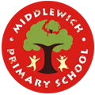
Thursday 24th April 2025

Middlewich Primary School
Park Road
Middlewich

Cheshire

Tel: 01606 652321
admin@middlewichpri.cheshire.sch.uk
Headteacher Mrs. G Reynolds

Dear Parents and Carers,

Children’s Shakespeare Festival Y5

As you know, your child’s class is taking part in the Northwest Drama Children’s Shakespeare Festival at the HOME theatre in Manchester Thursday 19th June 2025 at 2:30pm
The Performance is expected to last 1 hour and 15 minutes

If you would like to attend this event as an audience member, please see the separate letter regarding the purchase of tickets.

Clothing
On the day, please send your child in a school t-shirt and jumper. They should wear black leggings/trousers.

The children will wear a performance t-shirt and have bare feet on stage. School will place the order for the performance t-shirts to ensure consistency. Please also see the separate letter regarding t-shirt orders.

Our Performance
5RS are the ‘Royal Players’ and will be on stage third. They will be wearing bright green t-shirts. This will be followed by other schools performing their parts. 5CS are the ‘Virtue Players’ and are on stage sixth. 5CS will be wearing orange t-shirts.

What to bring
Please provide your child with a substantial packed lunch, snack and a couple of drinks as they will be at the theatre all day. You may order a lunch bag from the school kitchen if you wish (cost £2.90).

Please send your child with a coat and small bag to keep their lunch and jumper in.

Timings
Year 5 will be leaving school at 8am. Children should arrive at school at 7.45am prompt.
We expect to arrive back to Middlewich at approximately 5:00pm. The children should be collected from Home Bargains car park please.

Please complete the permission form via the link below:

https://forms.office.com/e/hu2A2pDXM1

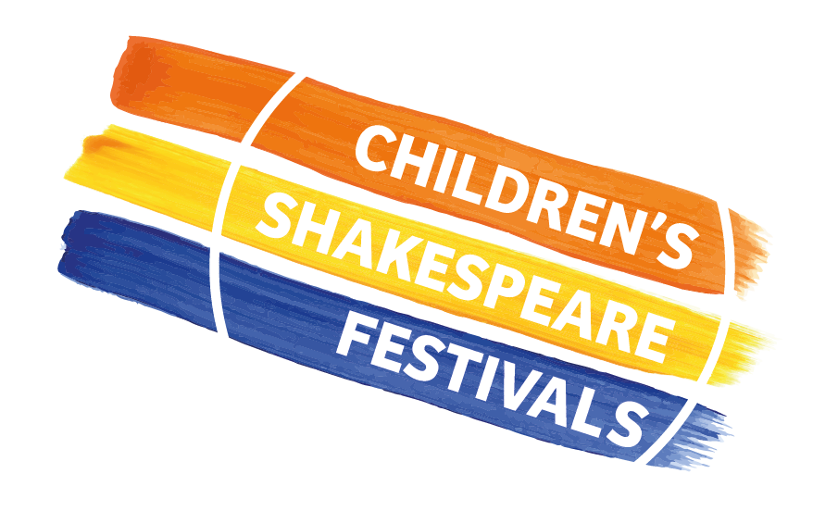
If you have any questions or would like more information, please contact your child’s teacher.

We look forward to sharing the children’s wonderful work with you all.

Mrs Stevens and Miss Semple
Year 5 class teachers

